**Web based FE issues**

1. **Cart -> Detail page**

* Footer wrong position and blocking staff ratio

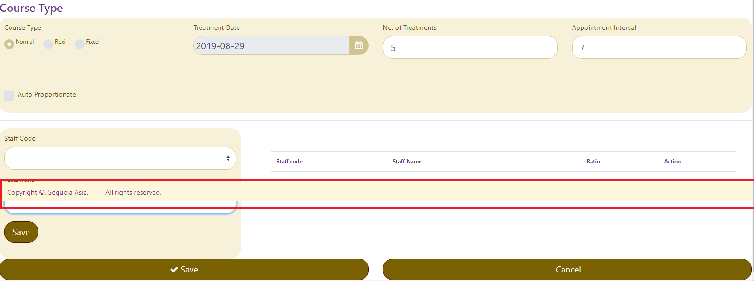

Corrected ok –(1)

**2)Staff selection no working**

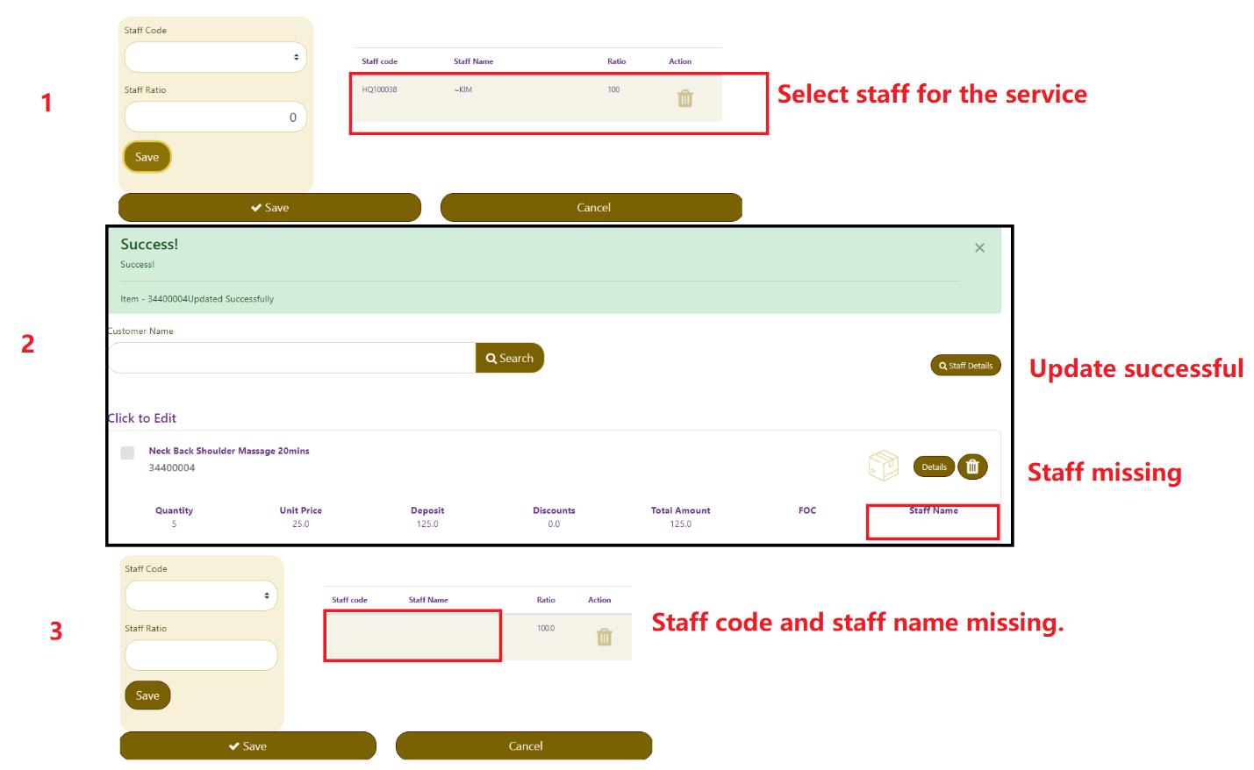

Corrected ok - (2)

**3)Cart -> Search**

* After clear the word in the ‘search box’, the name list still there

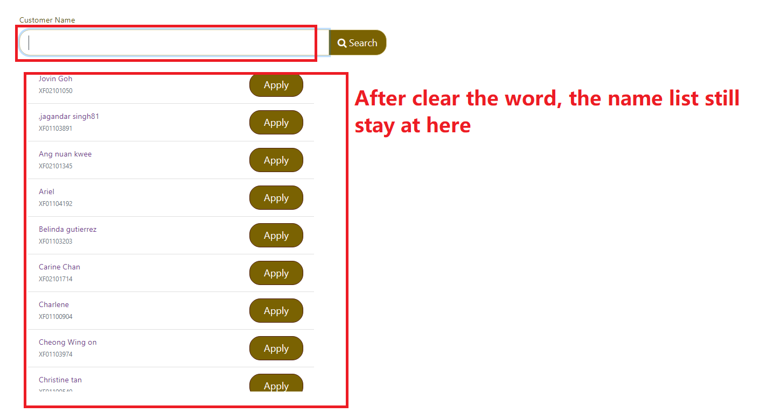

Corrected ok - (3)

* Can’t make payment

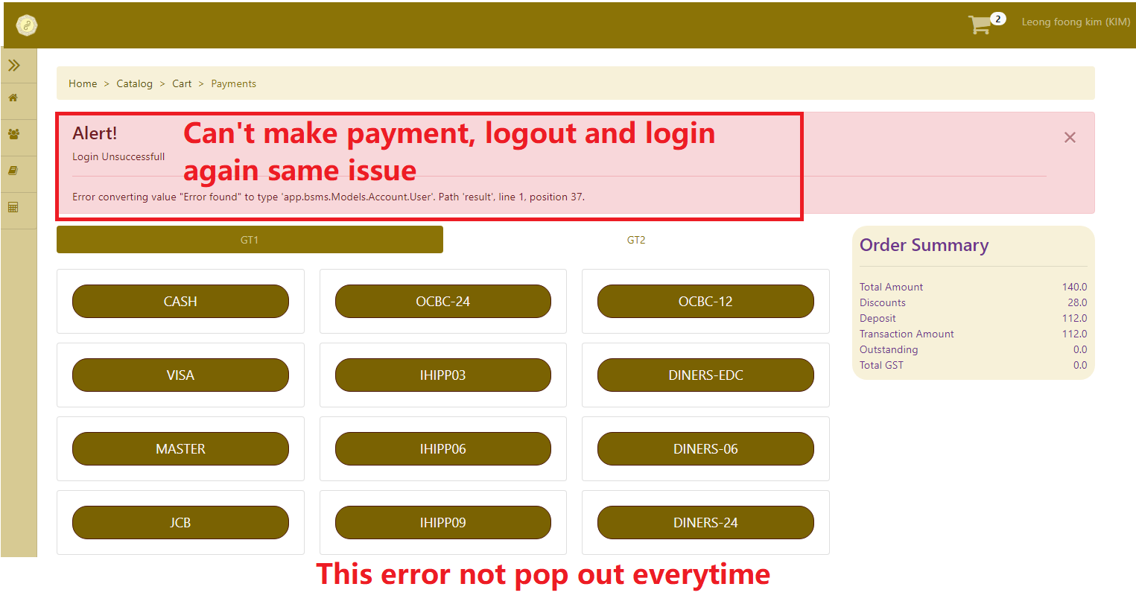

Create new customer - **Not Corrected (pending)**

* Saved data, but no showing

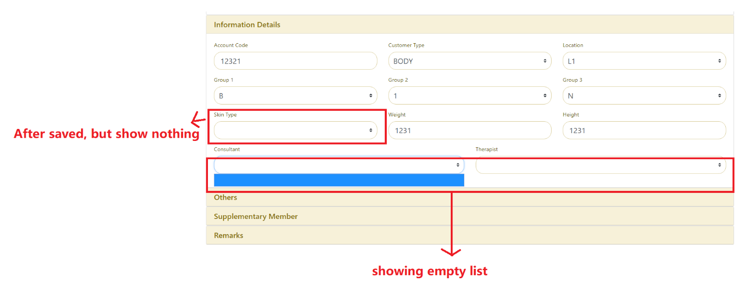

**4)** Update ‘anniversary’ but no chance.

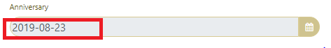

Corrected ok - (4)

Create new customer without insert reference code showing wrong message – **Not corrected**

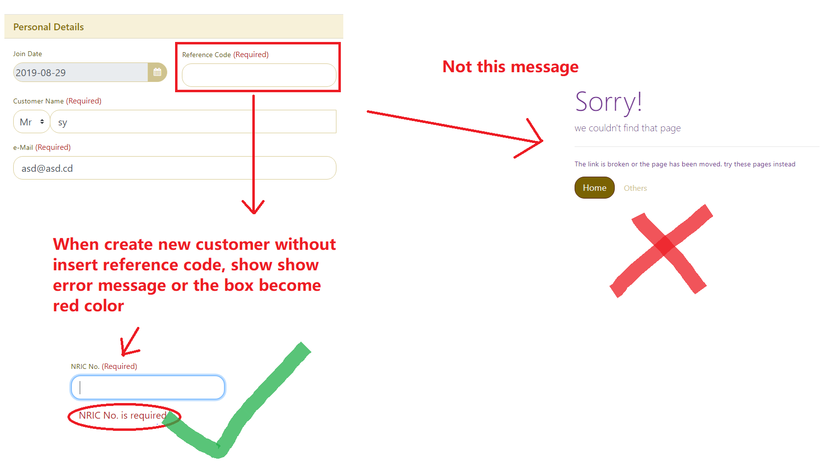

5) -search customer ‘123’, but showing others customer’s info

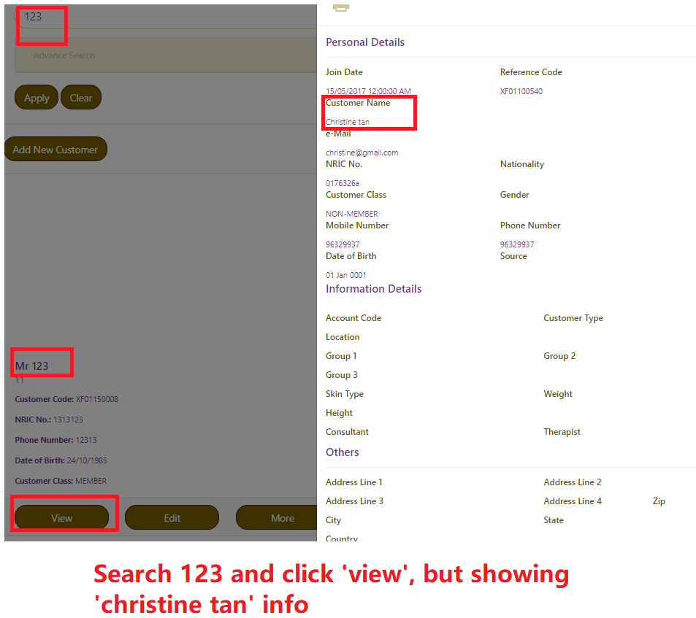

Corrected ok - (5)

Search Item

* Search result, position wrong

